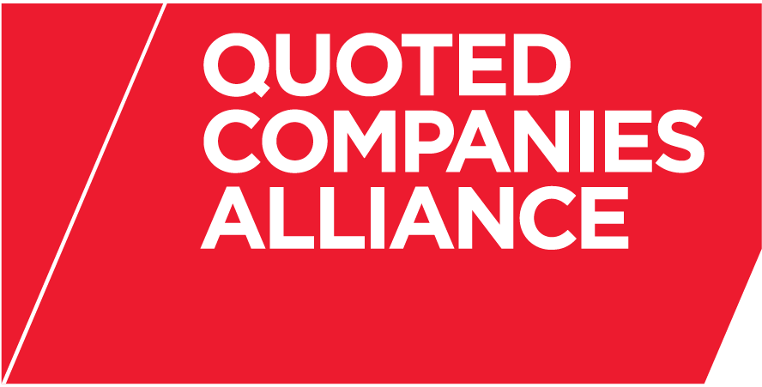

THE QUOTED COMPANIES ALLIANCE
SHARE SCHEMES EXPERT GROUP
PROPOSED MEETING DATES FOR 2013

All at 5.30pm unless otherwise advised (approx every 3 months)

Thursday 7 February 2013

Thursday 16 May 2013

Thursday 5 September 2013

Thursday 5 December 2013

